HOMEWORK: Connecting & Shaping Data

Using your Adventure Works Power BI file, complete the following:

**1)**Create new queries to connect to the **AdventureWorks_Product_Categories***(00:50 mark)* and **AdventureWorks_Product_Subcategories***(01:30 mark)* files from the course resources:

* Name you queries **AW_Product_Category_Lookup** and **AW_Product_Subcategory_Lookup***(01:00 mark)*
  + 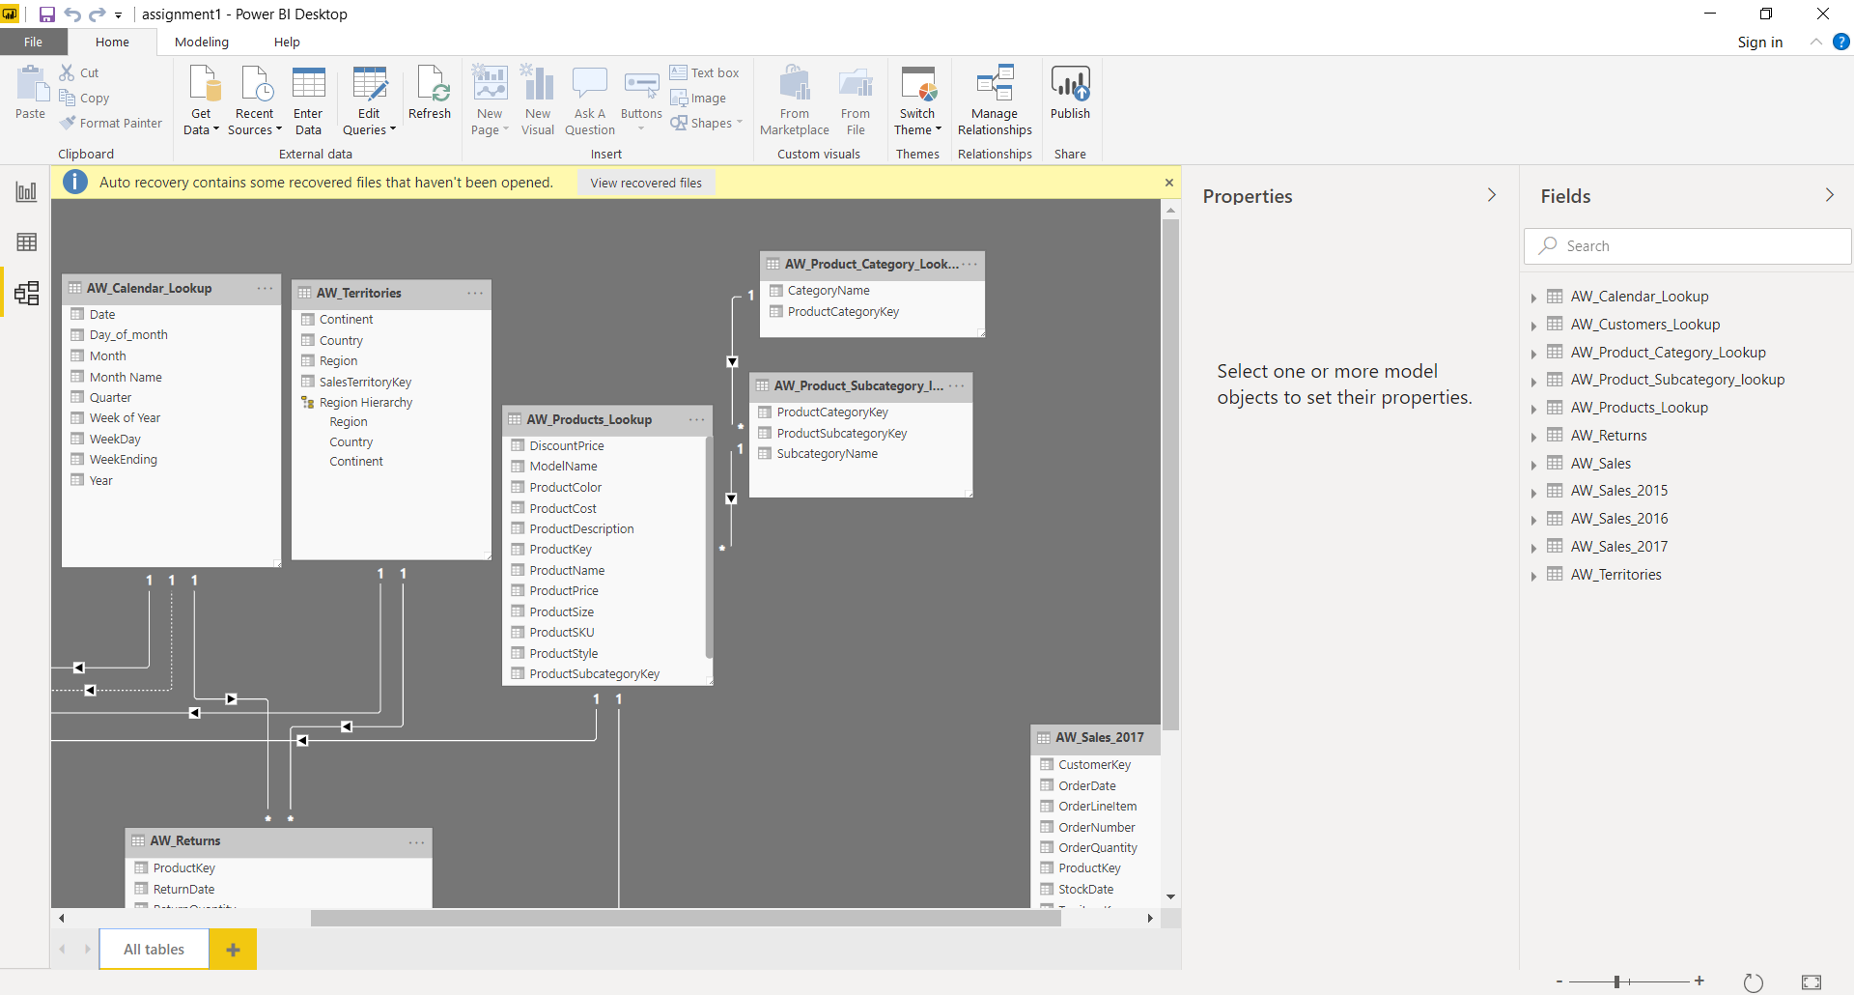
* Confirm that headers have been promoted and that detected data types are correct *(01:18 mark)*
* Disable the report refresh option for both connections *(02:14 mark)*

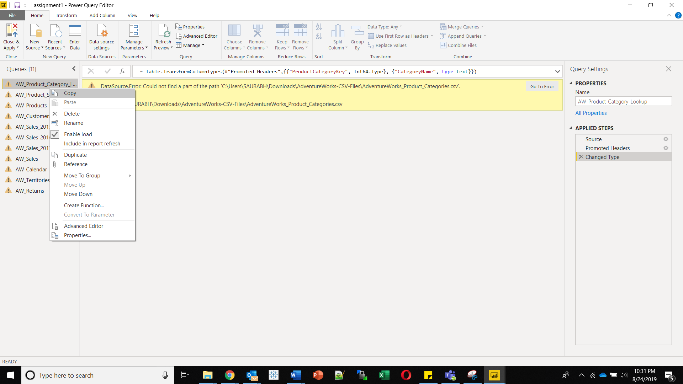

**2)** Make the following modifications to the **AW_Product_Lookup**query *(02:40 mark)*:

* Add a calculated column that extracts all characters before the dash ("-") in the **ProductSKU** column, named "**SKUType**" *(02:45 mark)*
* Update the **SKUType** calculation above to return all characters before *second*dash, instead of the first *(03:37 mark)*
* 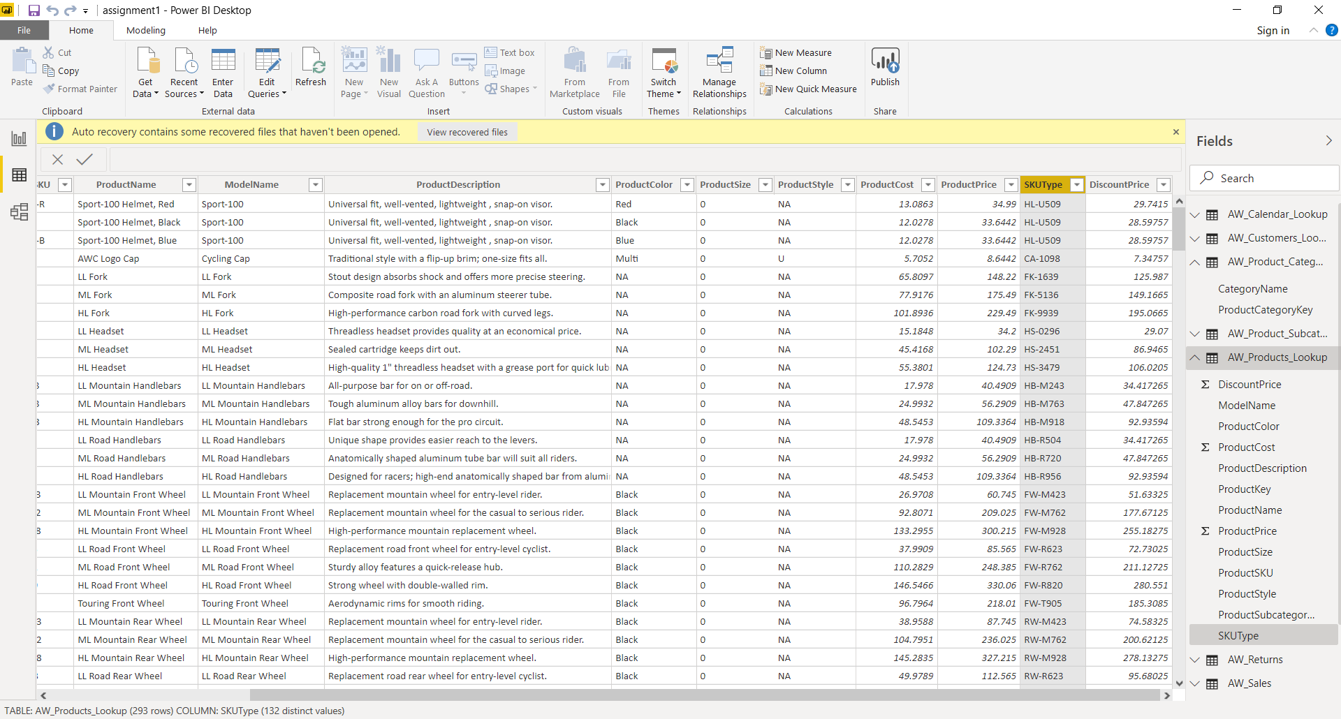
* Replace zeros (0) in the **ProductStyle** column with "*NA*" *(04:30 mark)*
* 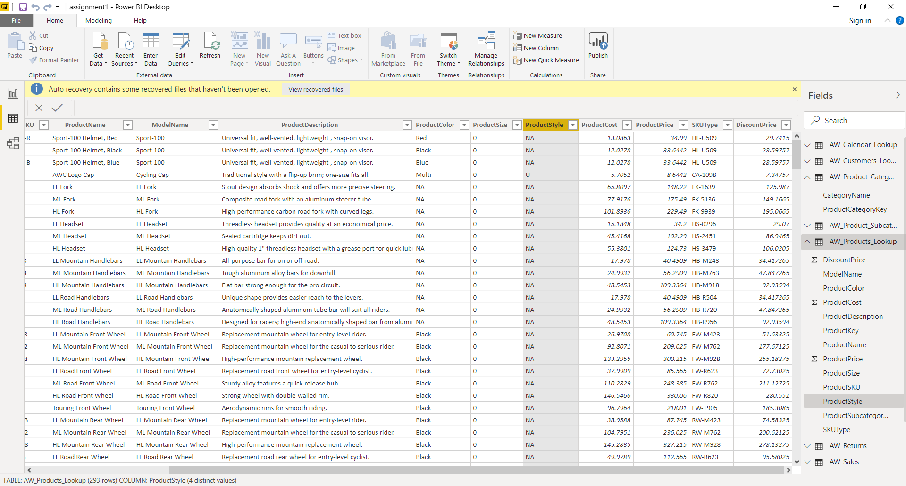
* Update the **DiscountPrice** calculation to 15%, by multiplying the **ProductPrice** values by 0.85*(instead of 0.9) (05:12 mark)*

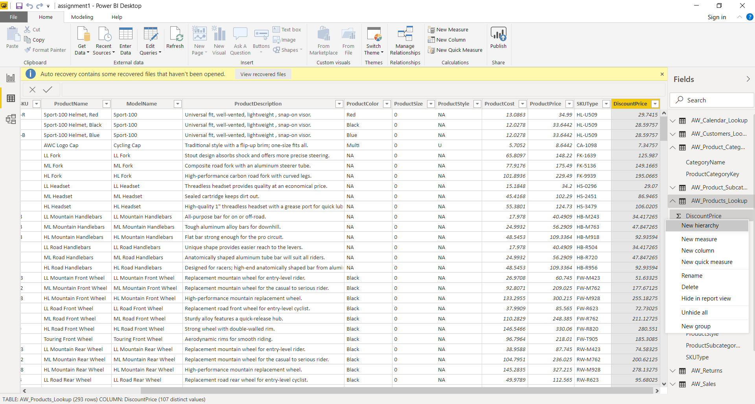

**3)** Using the Statistics tools in the Query Editor, confirm the following values *(06:04 mark)*:

* Average product cost (***$413.66***) *(06:12 mark)*
* Number of distinct product colors (***10***) *(06:43 mark)*
* Number of distinct customer names (***18,110***) *(07:11 mark)*
* Maximum annual customer income (***$170,000***) *(07:37 mark)*
* Count of order numbers (***56,046***) *(07:56 mark)*
* Count of distinct order numbers (***25,164***) *(08:17 mark)*

|  |
| --- |
| * Average Product Cost |
|  |
| Count Distinct Product Colors |
|  |
| Number of distinct customer names (18,110) |
|  |
|  |
| Maximum annual customer income ($170,000) |
|  |
|  |
| Count of order numbers (56,046) |
|  |
| Count of distinct order numbers (25,164) |
|  |

**4)**Make the following modifications to the **AW_Customer_Lookup** query *(08:58 mark)*:

* Add a new calculated column for the year of birth (named "**BirthYear**"), based on**BirthDate***(09:05 mark)*
* Add a conditional column to categorize customer income (named "**IncomeLevel**"), based on the following criteria *(09:34 mark)*:
  + If **AnnualIncome** >= $150,000, then **IncomeLevel** = "*Very High*"
  + If **AnnualIncome** >= $100,000, then **IncomeLevel** = "*High*"
  + If **AnnualIncome** >= $50,000, then **IncomeLevel** = "*Average*"
  + Otherwise **IncomeLevel** = "*Low*"

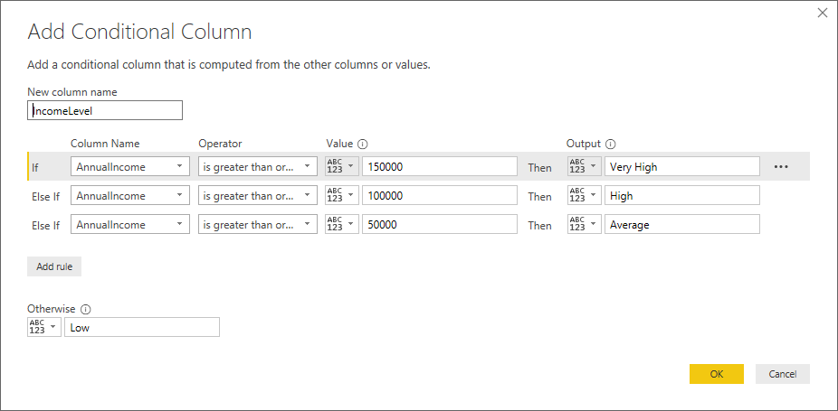

**5)** Apply all changes, and confirm that new tables and fields are accessible within both the **Data** and **Relationships** views (recommend saving a backup copy of the report (i.e. *"AdventureWorks_Report_Backup"*)) *(11:34 mark)*